

**Names**: Mugabo Aaron

**ID:** 25096

Assignment:

1. Concatenate first and last name:

SELECT CONCAT(first_name, ' ', last_name, ' - 25096') AS full_name FROM employees;

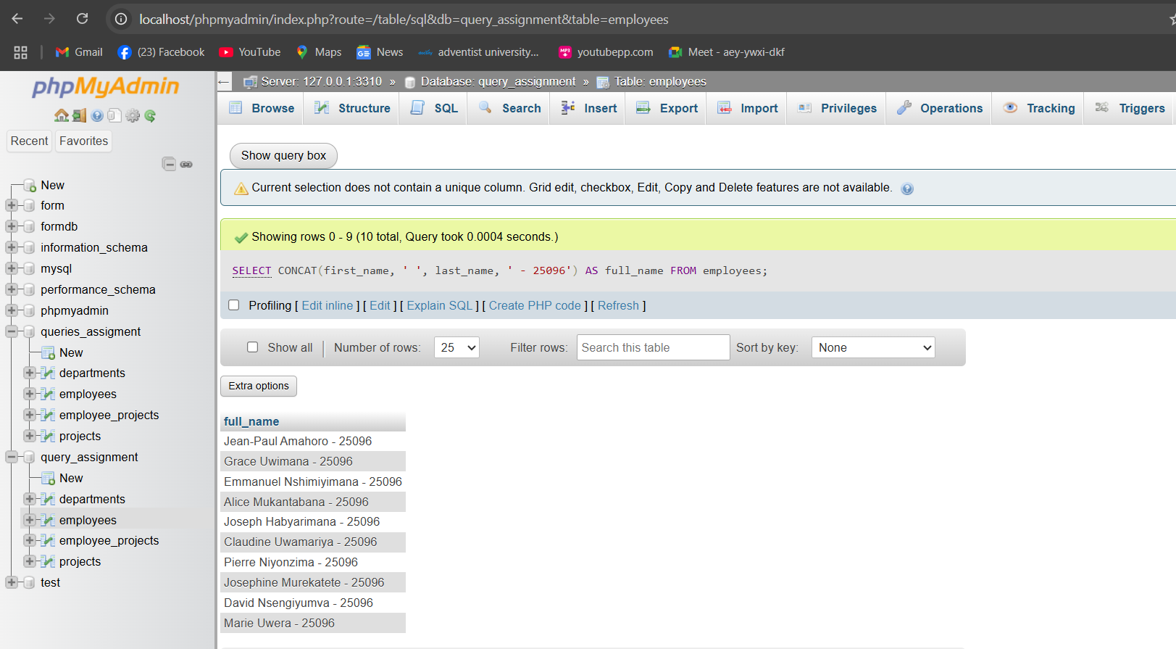

1. Convert names to lowercase:

SELECT CONCAT(LOWER(CONCAT(first_name, ' ', last_name)), ' - 25096') AS lowercase_name FROM employees;

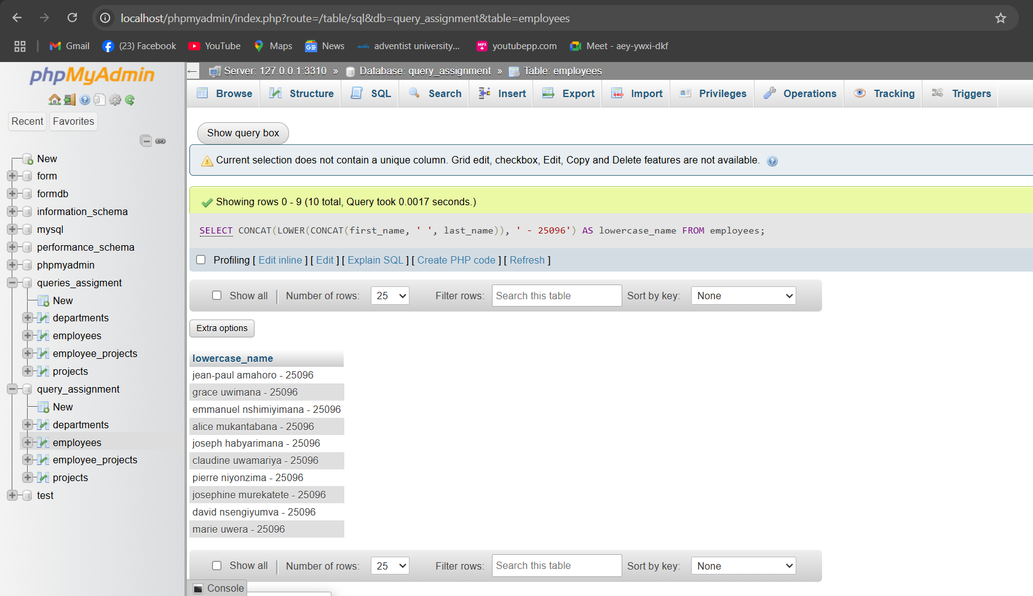

1. Extract first 3 letters of first_name:

SELECT CONCAT(SUBSTRING(first_name, 1, 3), ' - 25096') AS first_three_letters FROM employees;

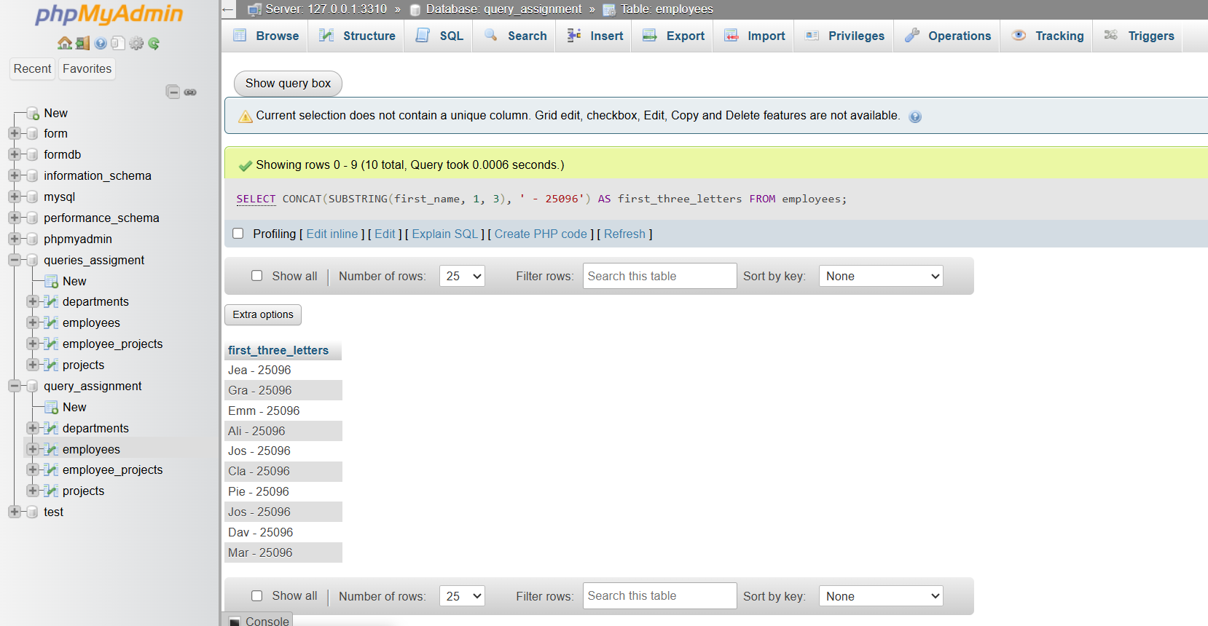

1. Replace '@company.com' in email with '@org.com'

SELECT CONCAT(REPLACE(email, '@company.com', '@org.com'), ' - 25096') AS new_email FROM employees;

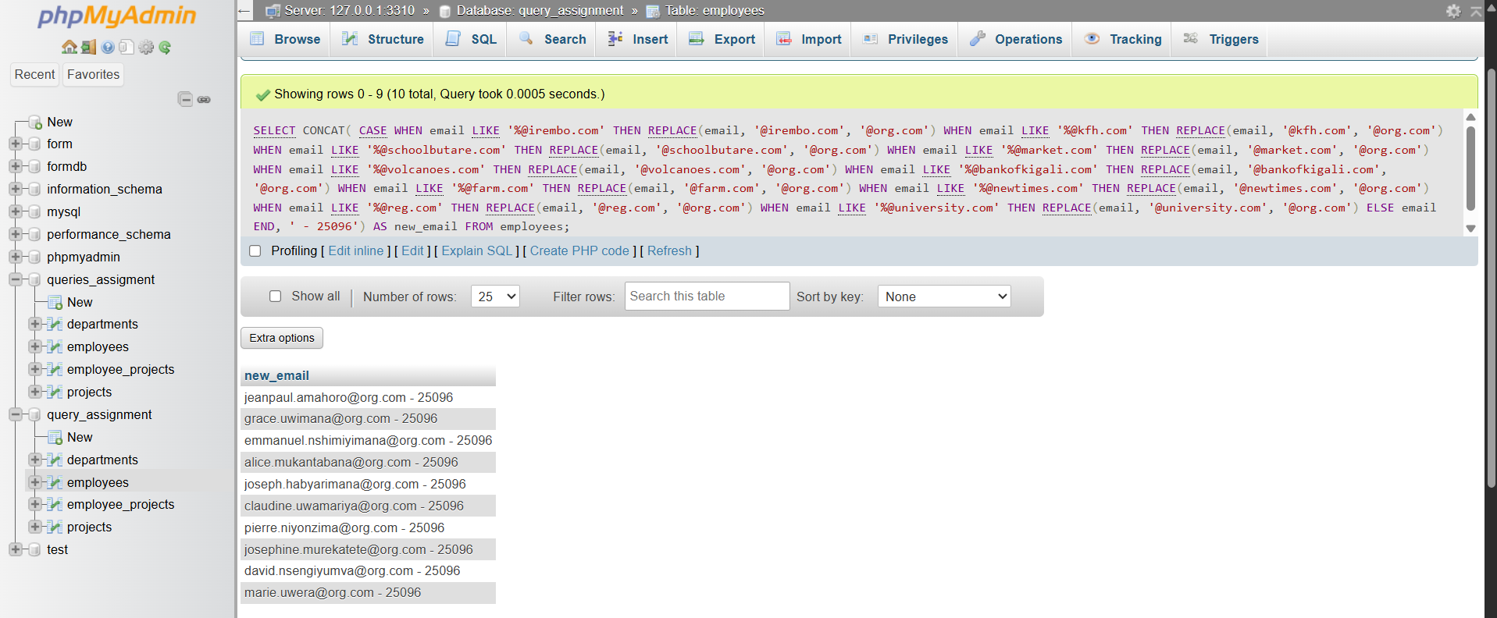

1. Trim spaces from a padded string

SELECT CONCAT(TRIM(' padded string '), ' - 25096') AS trimmed_string;

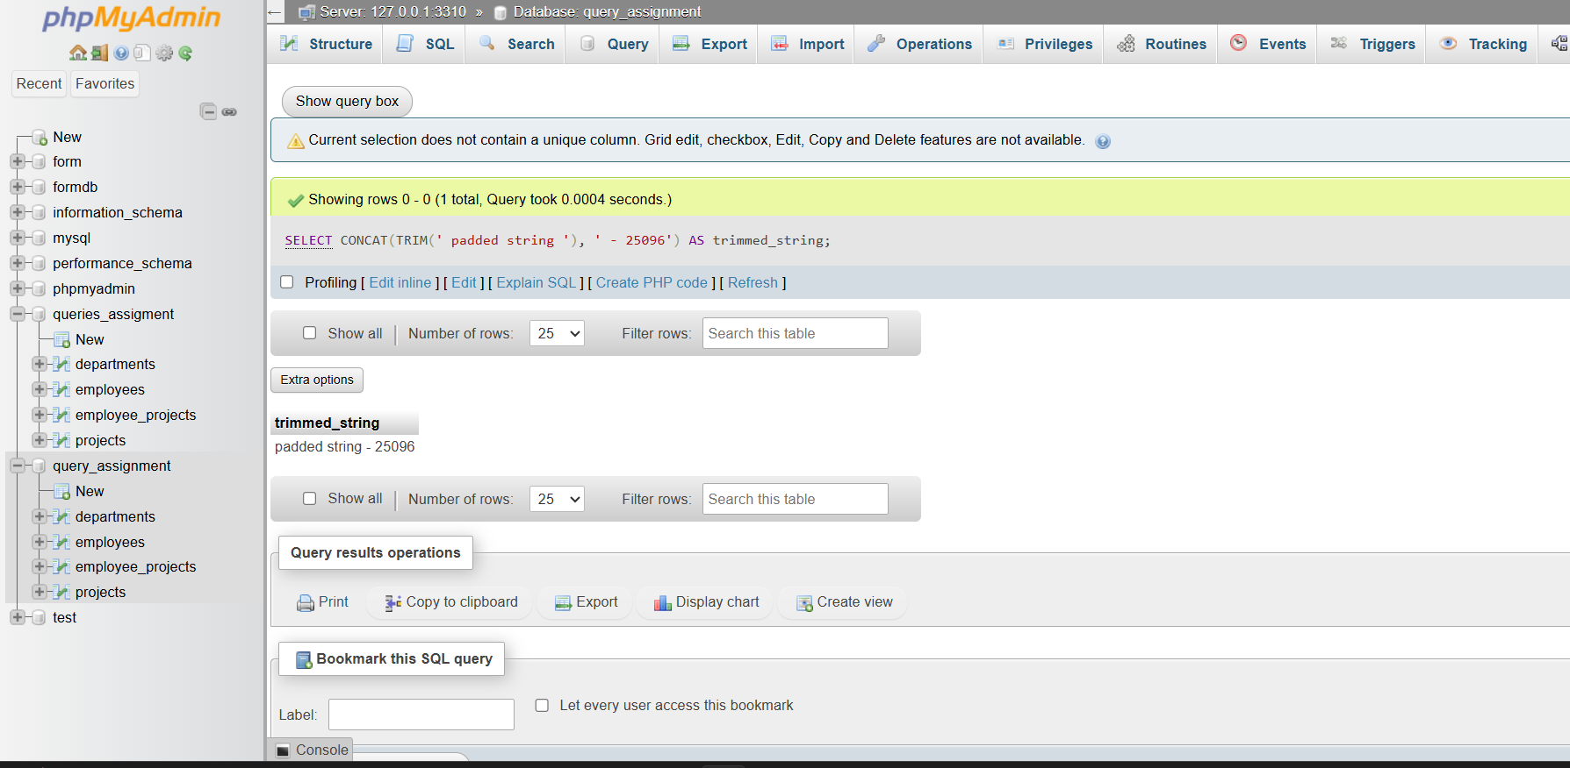

1. Count characters in an employee's full name

SELECT CONCAT(LENGTH(CONCAT(first_name, ' ', last_name)), ' - 25096') AS name_length FROM employees;

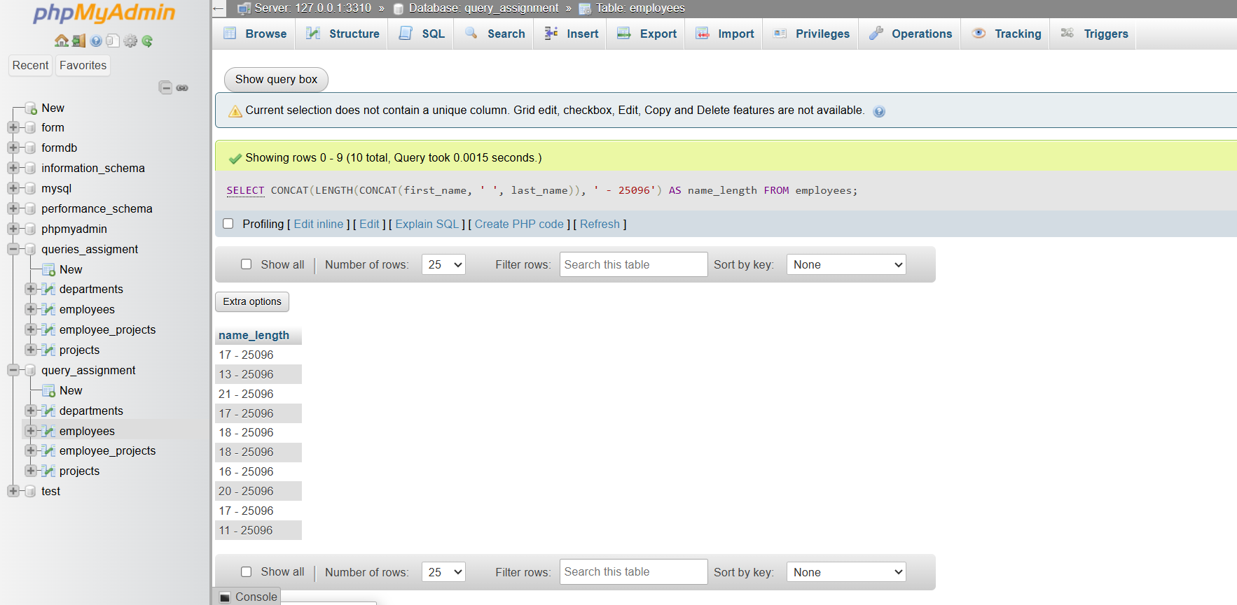

1. Find position of '@' in email using INSTR

SELECT CONCAT(INSTR(email, '@'), ' - 25096') AS at_position FROM employees;

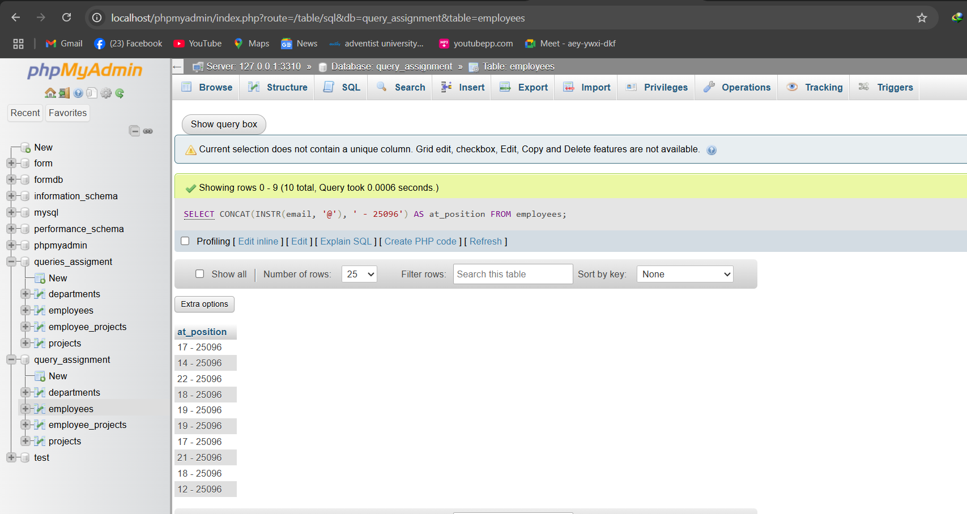

1. Add 'Mr' or 'Ms' before names based on gender

-- Add gender column temporarily for this exercise (not in original schema)

SELECT CONCAT(

CASE

WHEN gender = 'Male' THEN 'Mr '

WHEN gender = 'Female' THEN 'Ms '

ELSE ''

END, first_name, ' ', last_name, ' - 25096') AS titled_name

FROM employees;

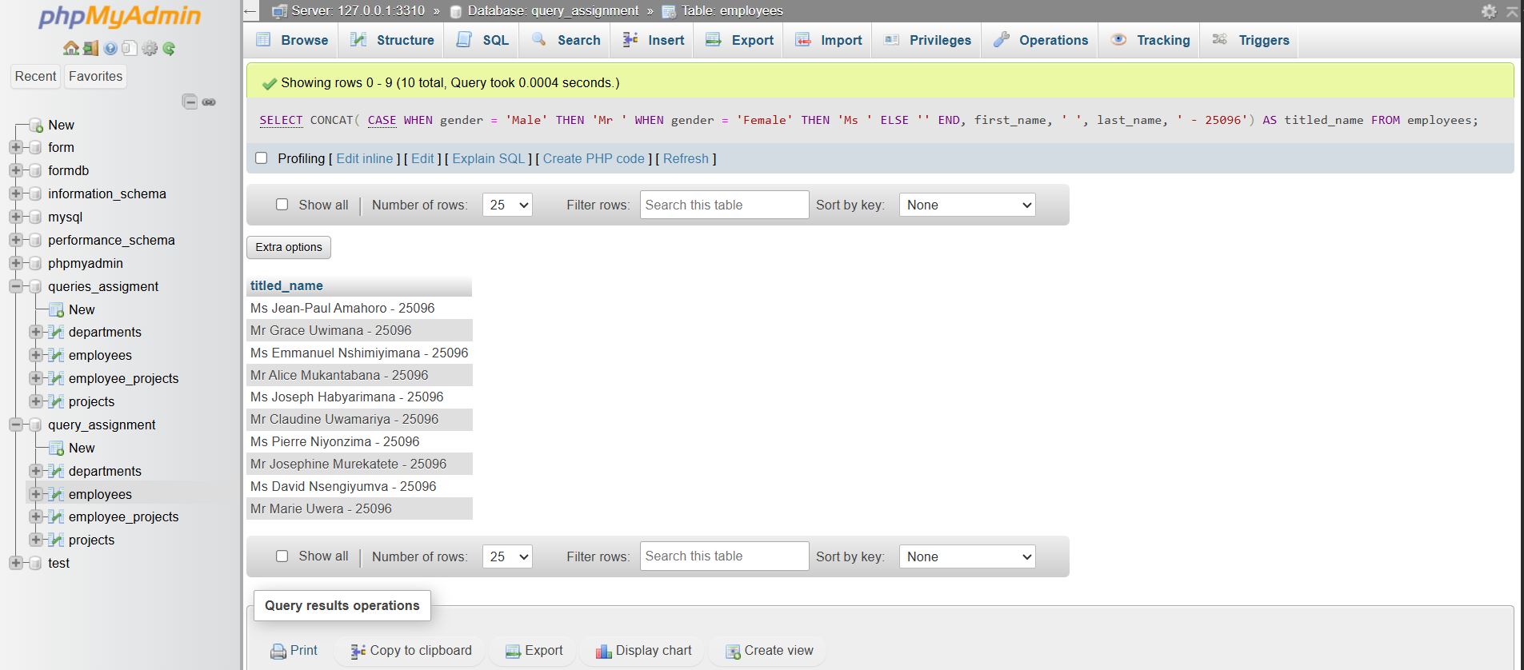

1. Format project names to uppercase

SELECT CONCAT(UPPER(project_name), ' - 25096') AS uppercase_project_name FROM projects;

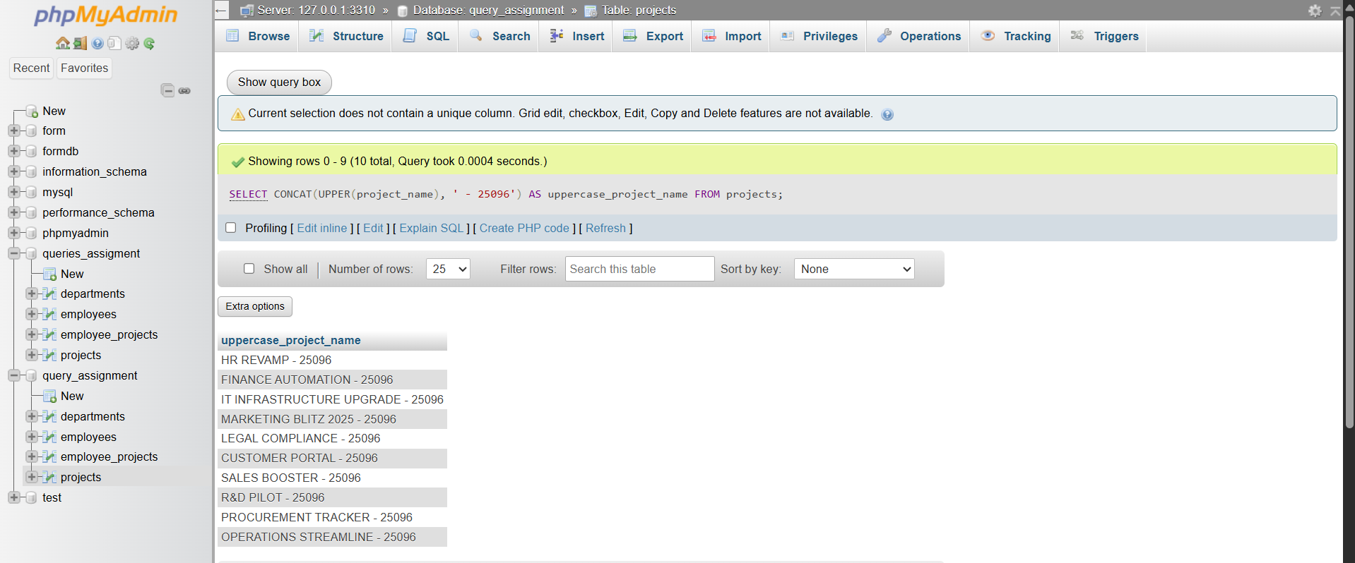

1. Remove any dashes from project names

SELECT CONCAT(REPLACE(project_name, '-', ''), ' - 25096') AS no_dash_project_name FROM projects;

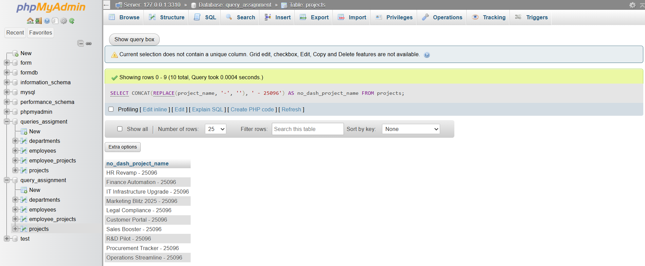

1. Create a label like "Emp: Jean-Paul Amahoro (Human Resources)"

SELECT CONCAT('Emp: ', e.first_name, ' ', e.last_name, ' (', d.department_name, ') - 25096') AS label

FROM employees e

JOIN departments d ON e.department_id = d.department_id;

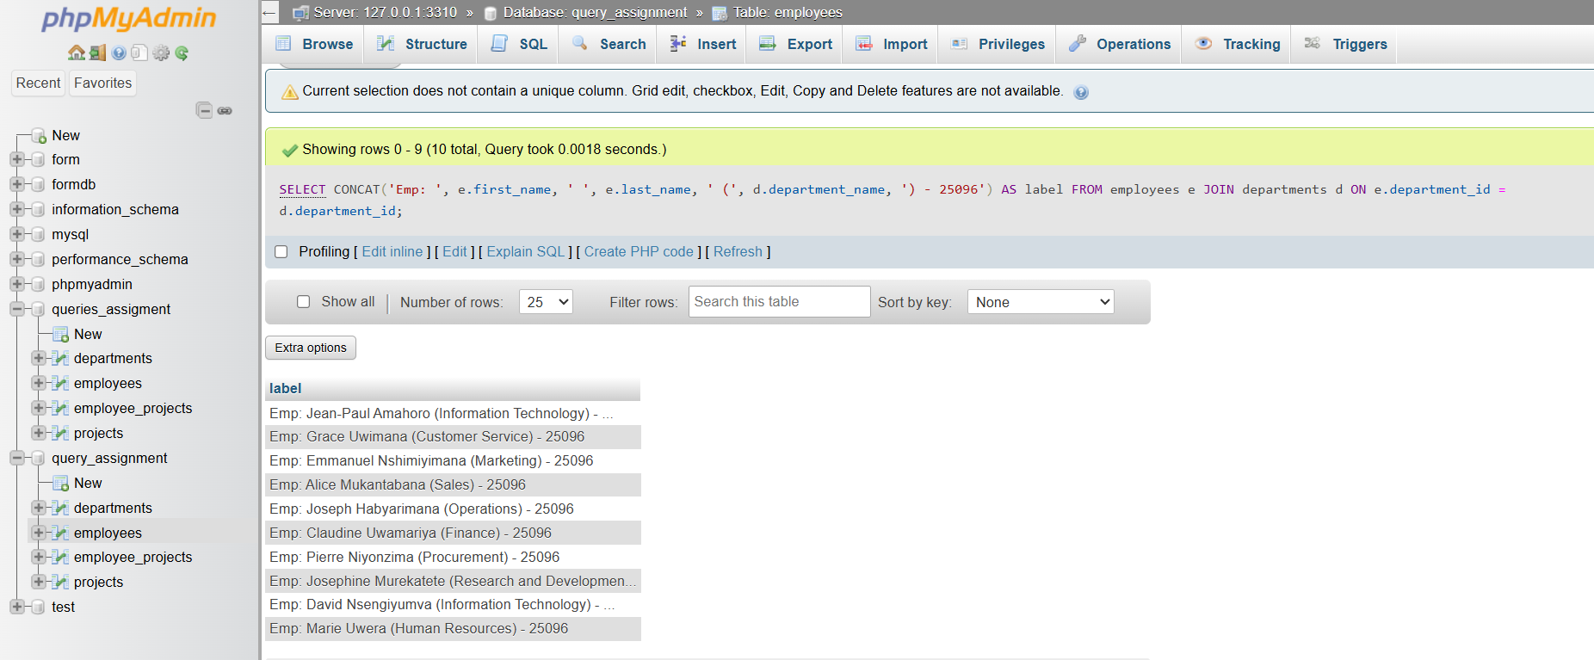

1. Check email length for each employee

SELECT CONCAT(LENGTH(email), ' - 25096') AS email_length FROM employees;

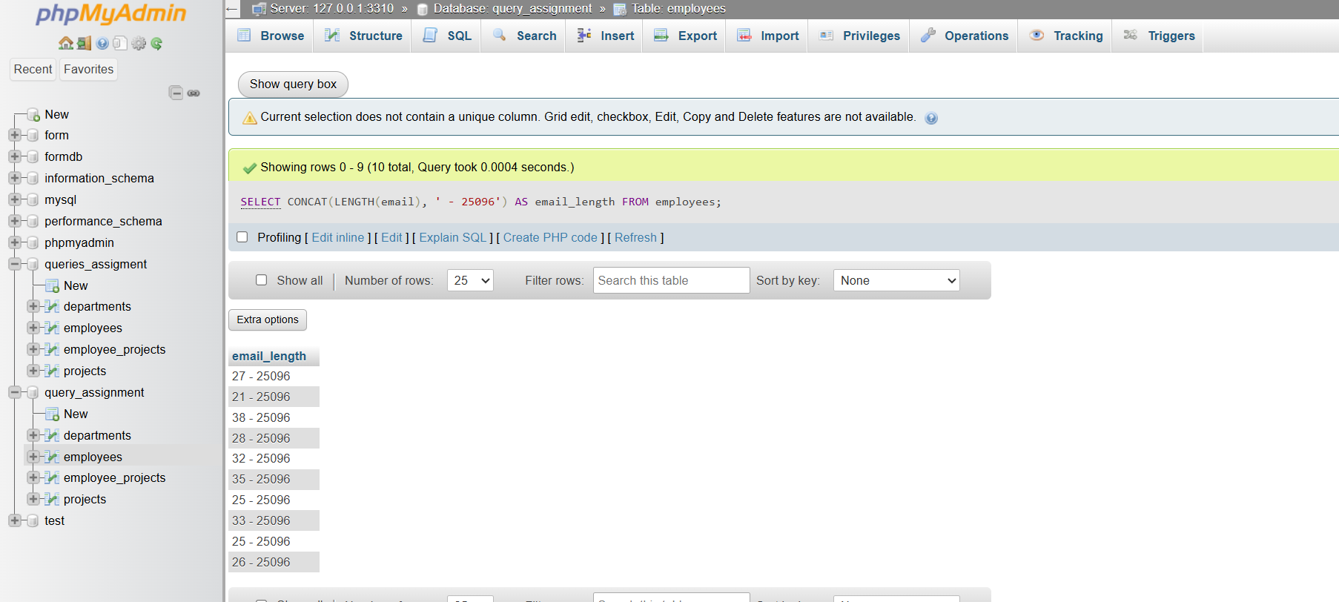

1. Extract last name only from email (between '.' and '@')

SELECT CONCAT(

SUBSTRING_INDEX(SUBSTRING_INDEX(email, '@', 1), '.', -1),

' - 25096') AS last_name_from_email

FROM employees;

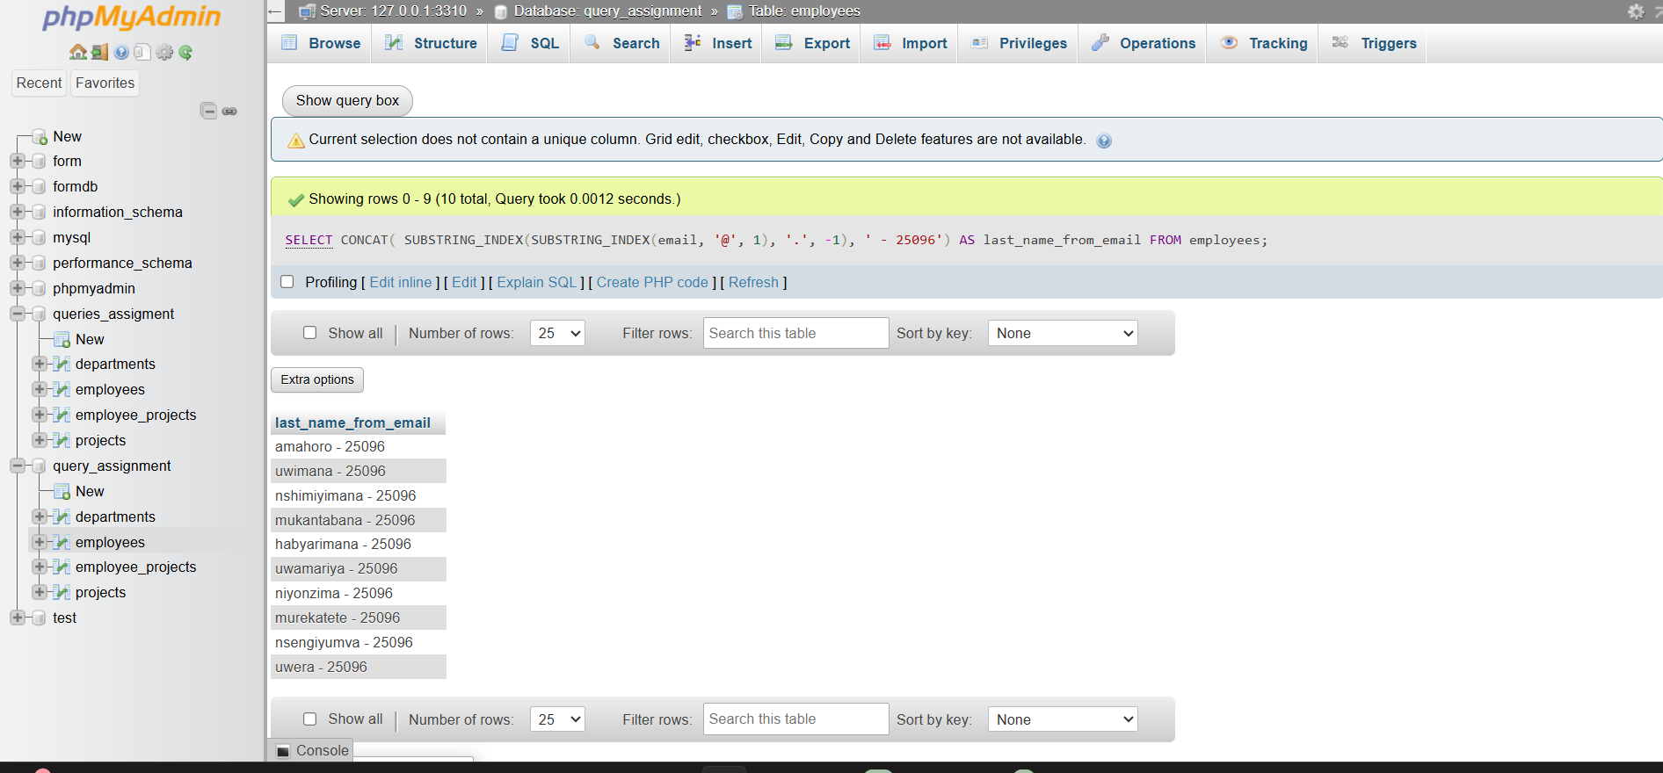

1. Format "LASTNAME. Firstname" using UPPER and CONCAT

SELECT CONCAT(UPPER(last_name), '. ', first_name, ' - 25096') AS formatted_name FROM employees;

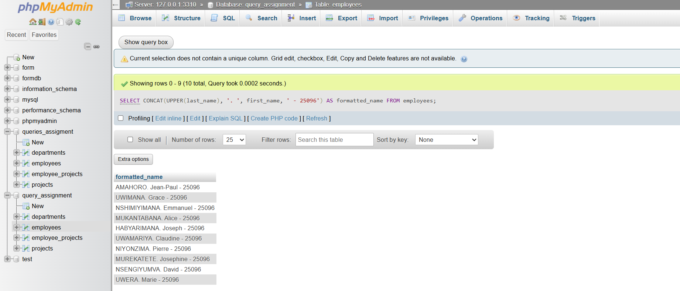

1. Add "(Active)" next to employee names who have current projects

SELECT CONCAT(

e.first_name, ' ', e.last_name,

CASE

WHEN COUNT(p.project_id) > 0 THEN ' (Active)'

ELSE ''

END, ' - 25096') AS employee_status

FROM employees e

LEFT JOIN employee_projects ep ON e.employee_id = ep.employee_id

LEFT JOIN projects p ON ep.project_id = p.project_id AND (p.end_date IS NULL OR p.end_date > CURRENT_DATE)

GROUP BY e.employee_id, e.first_name, e.last_name;

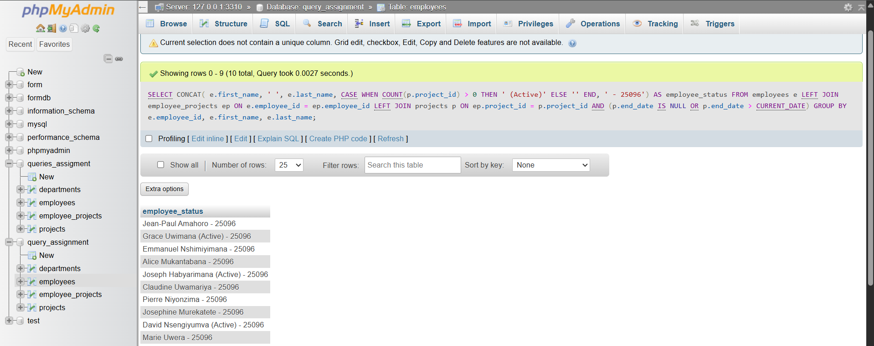

1. Round salary to the nearest whole number

SELECT CONCAT(ROUND(salary), ' - 25096') AS rounded_salary FROM employees;

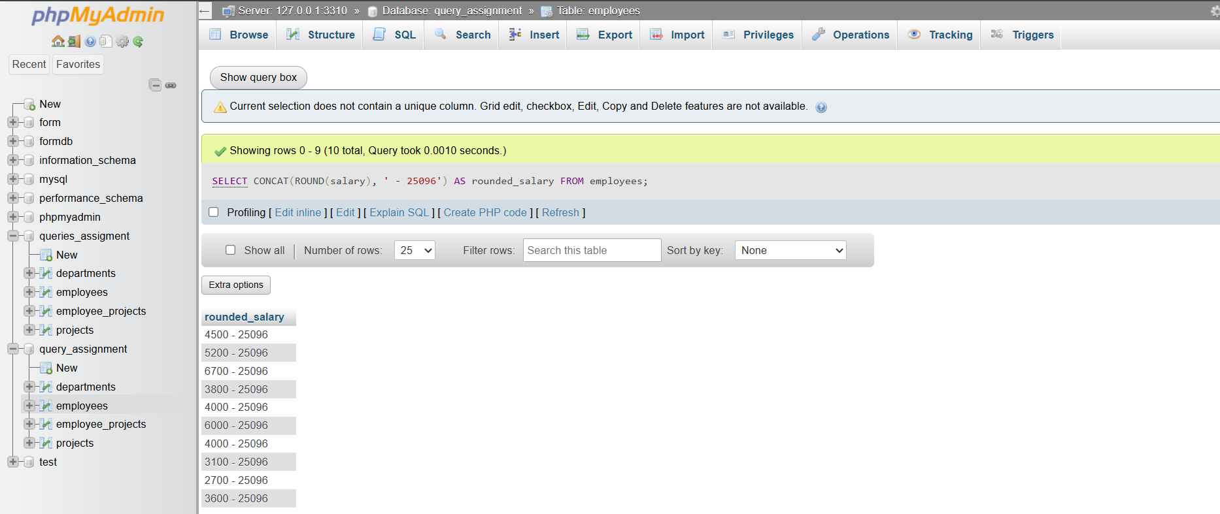

1. Show only even salaries using MOD

SELECT CONCAT(salary, ' - 25096') AS even_salary

FROM employees

WHERE MOD(FLOOR(salary), 2) = 0;

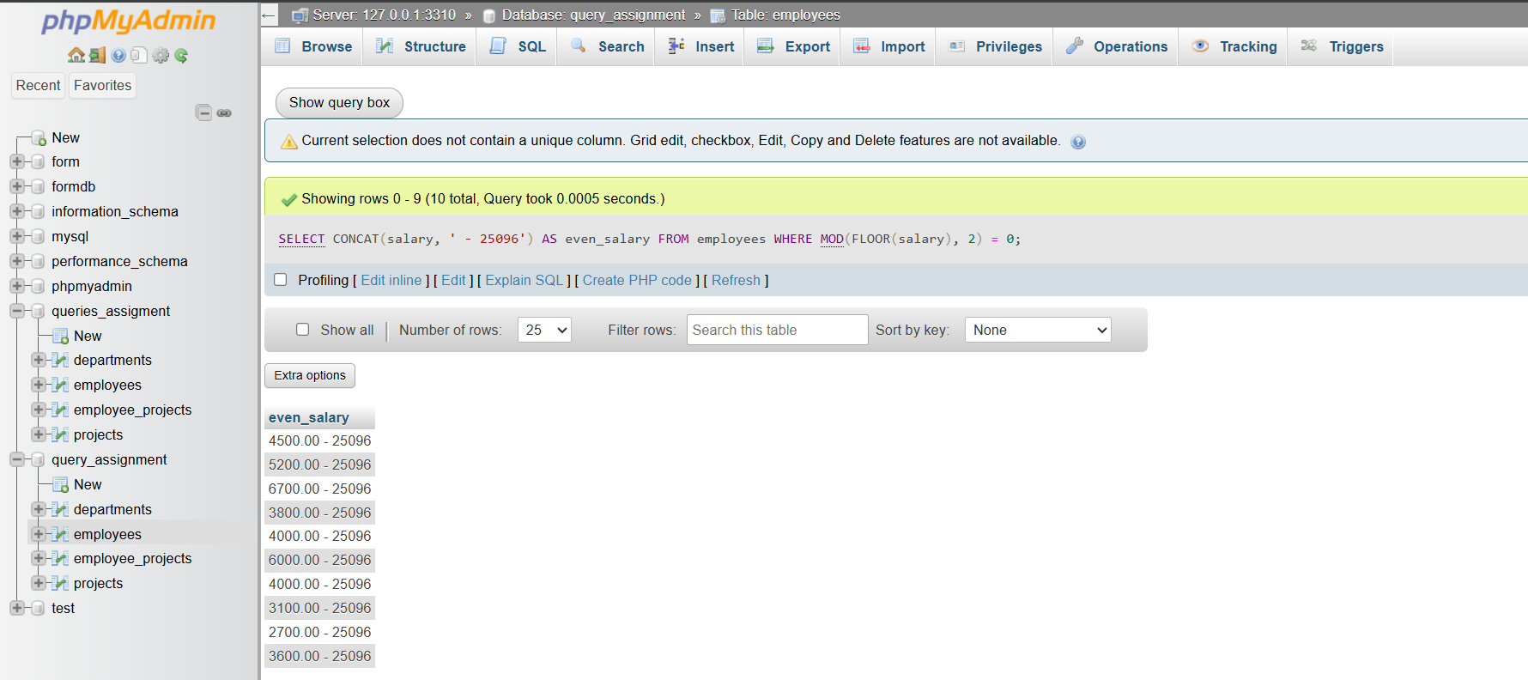

1. Show difference between two project end/start dates using DATEDIFF

SELECT CONCAT(DATEDIFF(end_date, start_date), ' - 25096') AS duration_days

FROM projects

WHERE end_date IS NOT NULL;

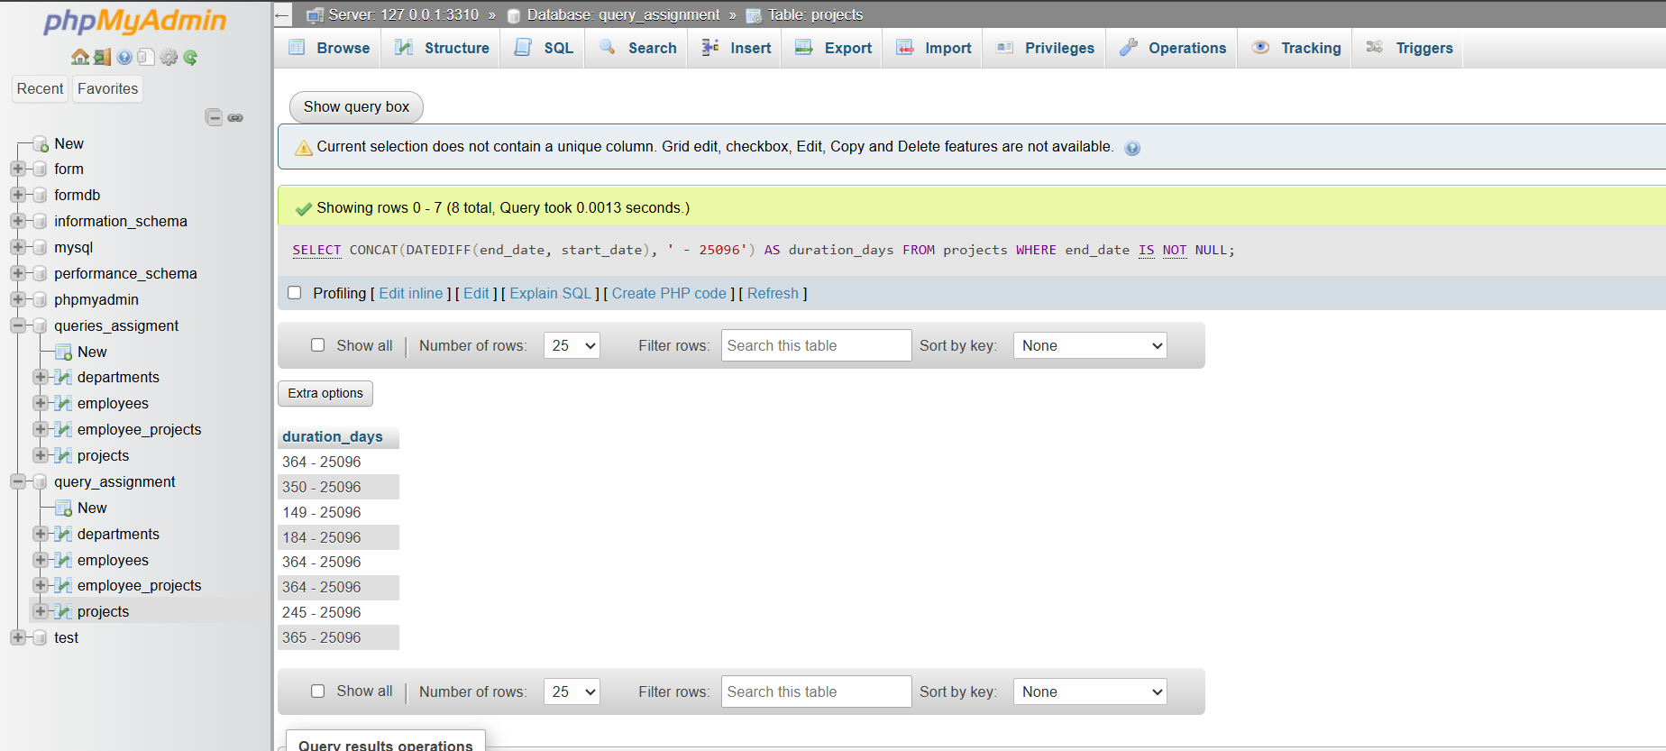

1. Show absolute difference in salaries between two employees (from average)

SELECT CONCAT(ABS(salary - (SELECT AVG(salary) FROM employees)), ' - 25096') AS diff_from_avg

FROM employees;

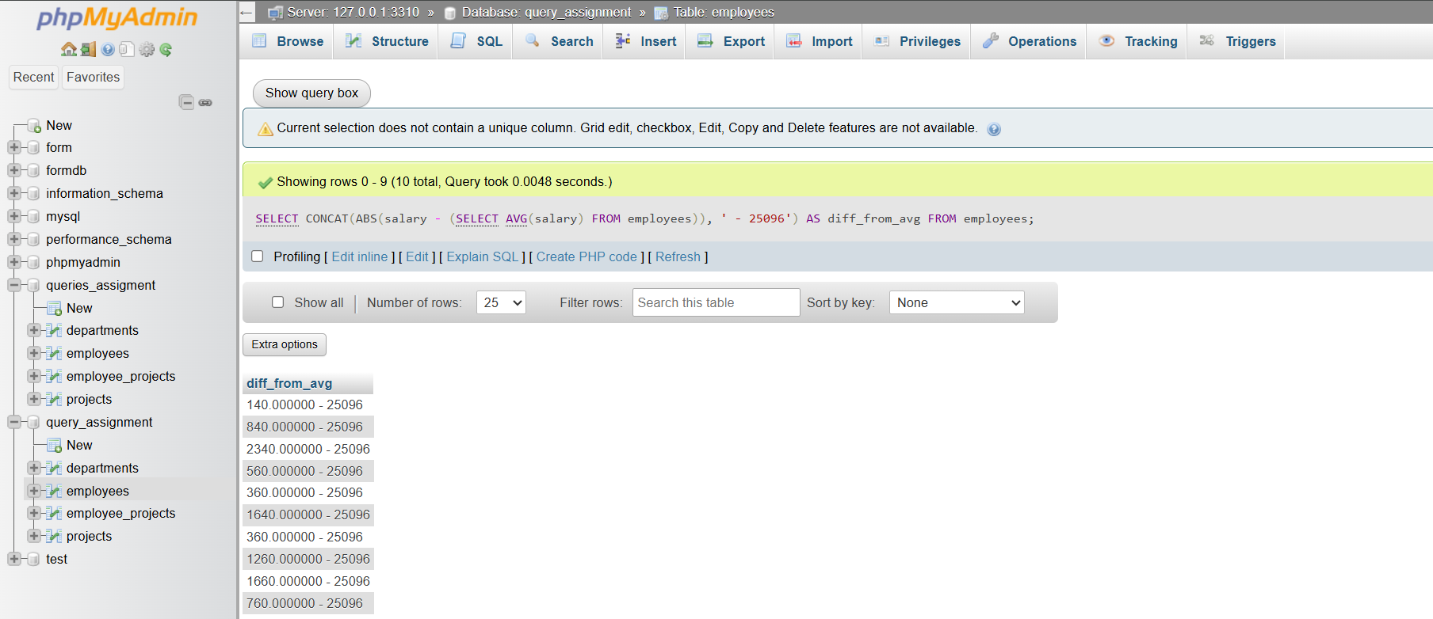

1. Raise salary by 10% using POWER

SELECT CONCAT(salary * POWER(1.1, 1), ' - 25096') AS raised_salary FROM employees;

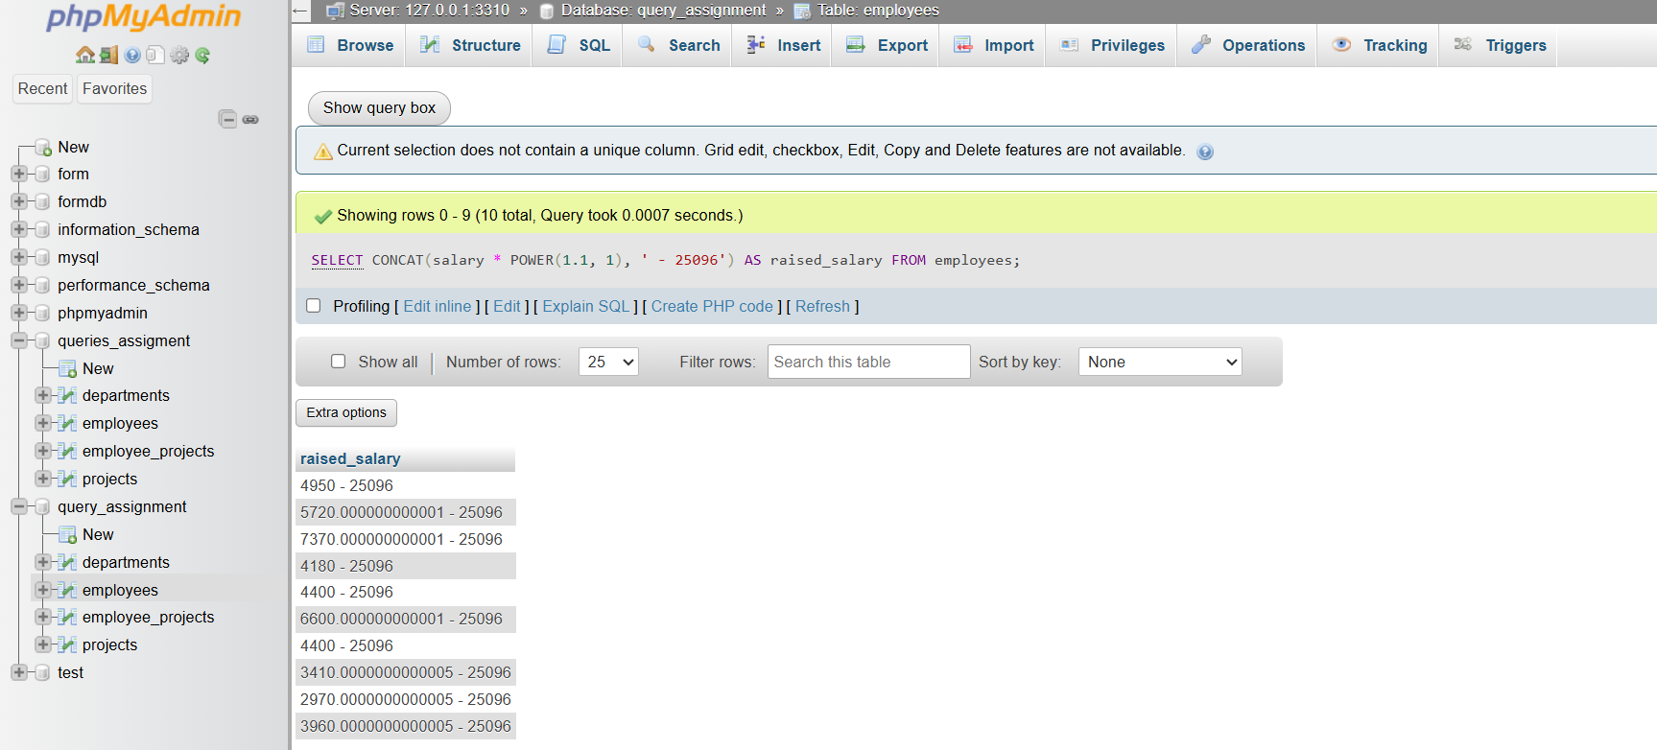

1. Generate a random number for testing IDs

SELECT CONCAT(FLOOR(RAND() * 1000), ' - 25096') AS random_id;

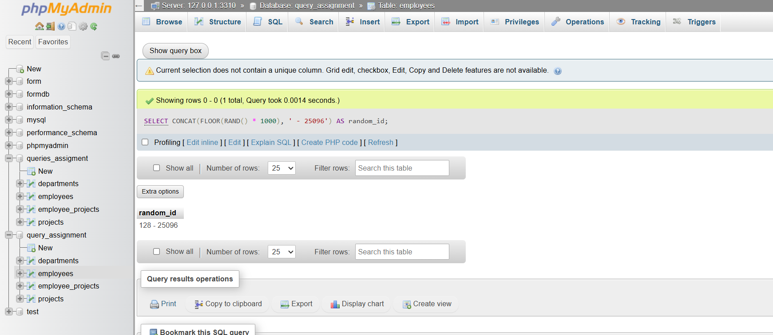

1. Use CEIL and FLOOR on a floating salary

SELECT CONCAT(CEIL(salary), ' - 25096') AS ceil_salary,

CONCAT(FLOOR(salary), ' - 25096') AS floor_salary

FROM employees;

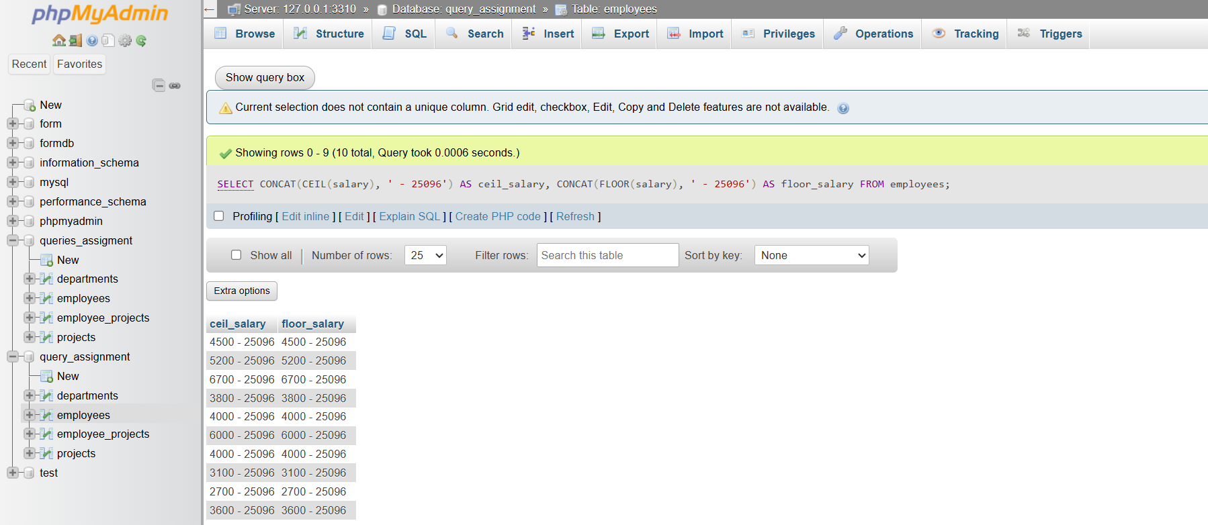

1. Use LENGTH() on phone numbers (using email since no phone column exists)

SELECT CONCAT(LENGTH(email), ' - 25096') AS email_length FROM employees;

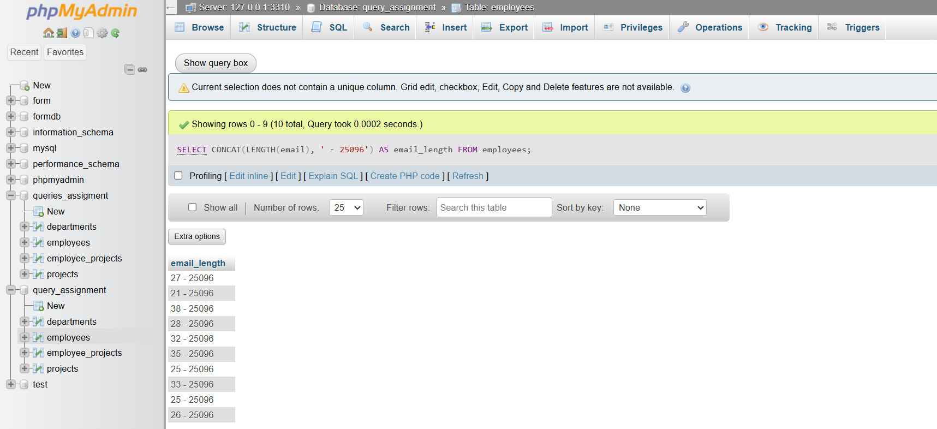

1. Categorize salary: High/Medium/Low using CASE

SELECT CONCAT(

CASE

WHEN salary >= 5000 THEN 'High'

WHEN salary >= 3000 THEN 'Medium'

ELSE 'Low'

END, ' - 25096') AS salary_category

FROM employees;

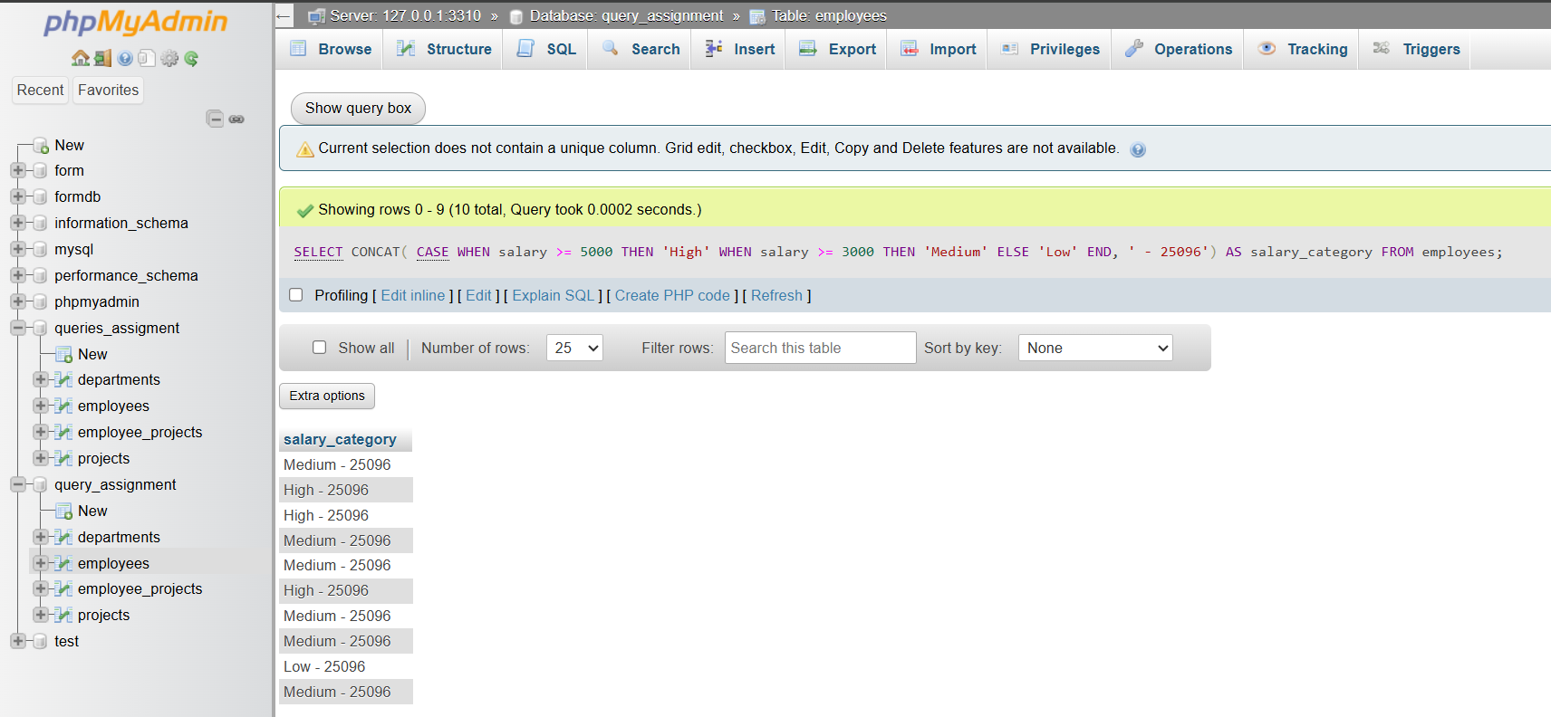

1. Count digits in salary amount (integer part

SELECT CONCAT(LENGTH(FLOOR(salary)), ' - 25096') AS digit_count FROM employees;

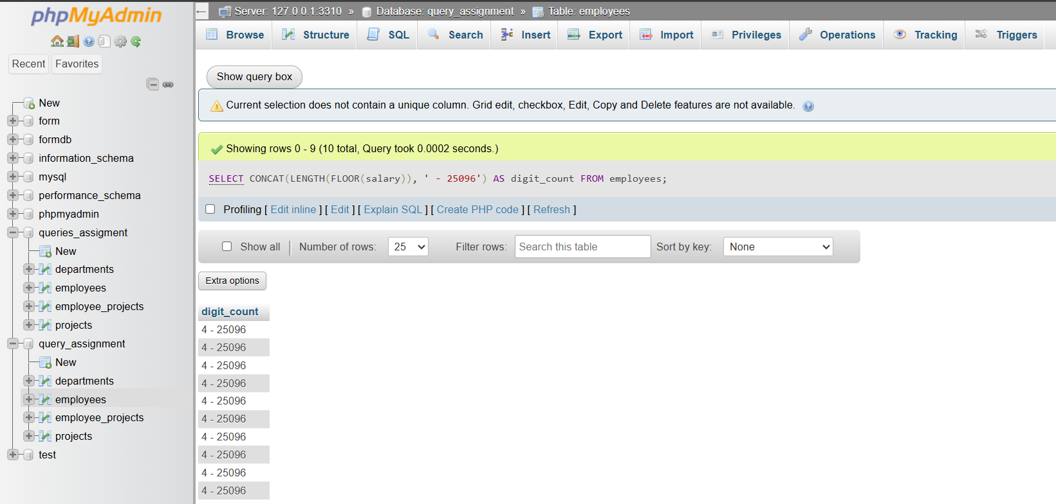

1. Show today’s date using CURRENT_DATE

SELECT CONCAT(CURRENT_DATE, ' - 25096') AS today;

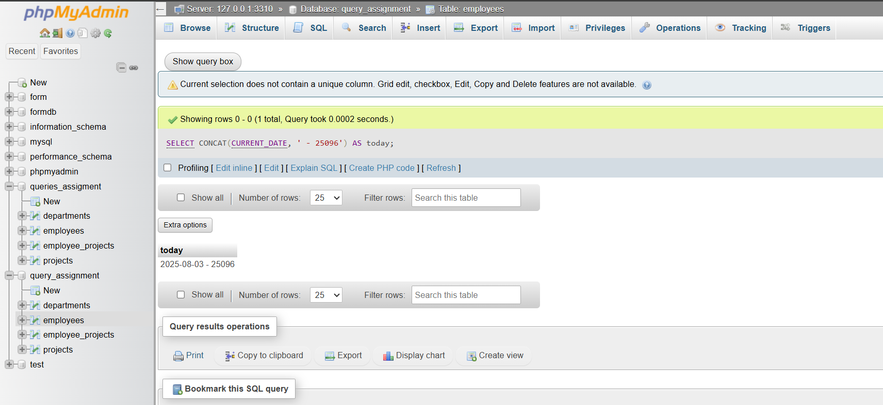

1. Calculate how many days an employee has worked

SELECT CONCAT(DATEDIFF(CURRENT_DATE, hire_date), ' - 25096') AS days_worked FROM employees;

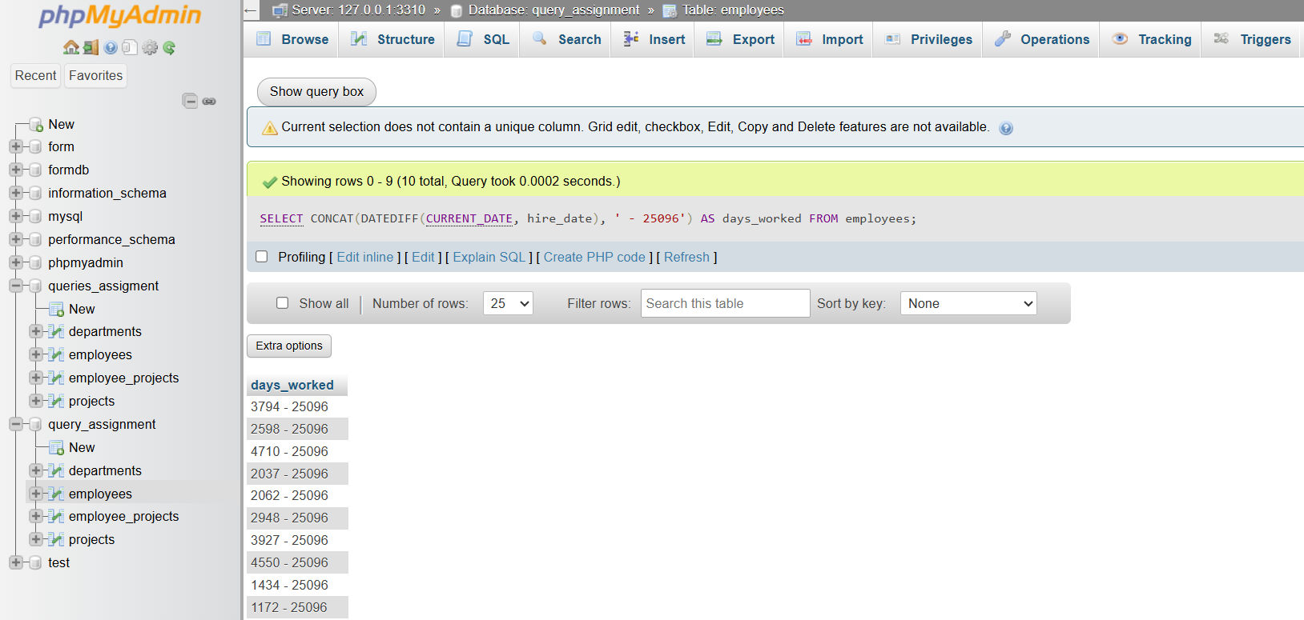

1. Show employees hired in the current year

SELECT CONCAT(first_name, ' ', last_name, ' - 25096') AS current_year_hires

FROM employees

WHERE YEAR(hire_date) = YEAR(CURRENT_DATE);

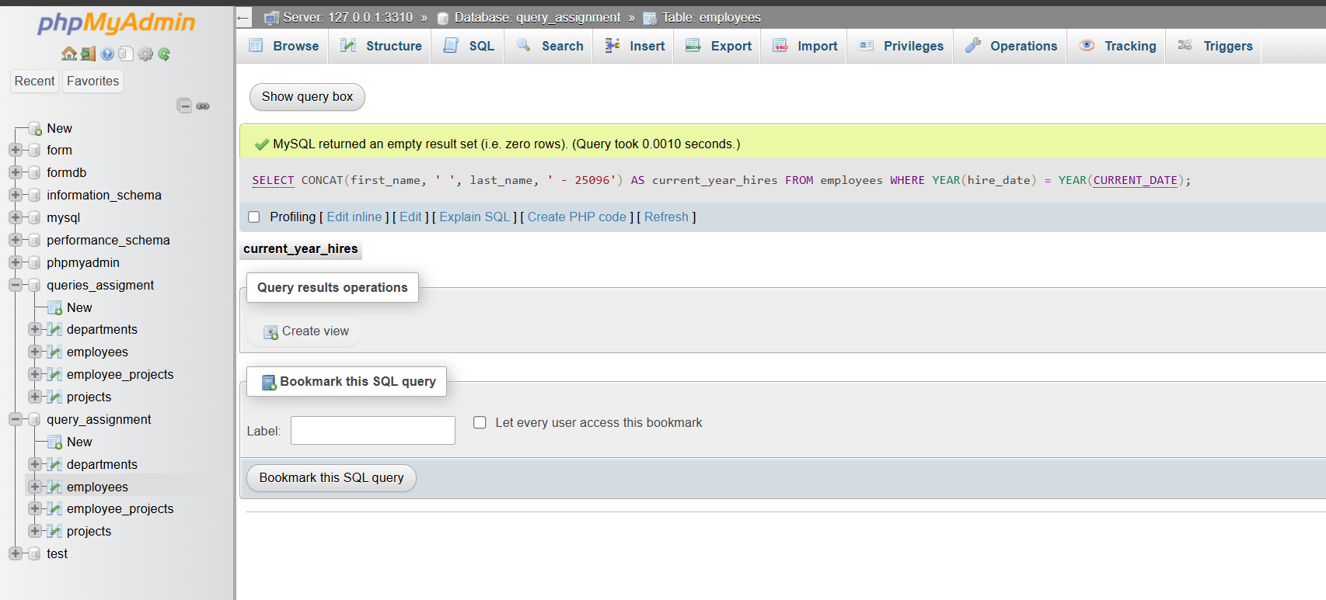

1. **Display current date and time using NOW()**

SELECT CONCAT(NOW(), ' - 25096') AS current_datetime;

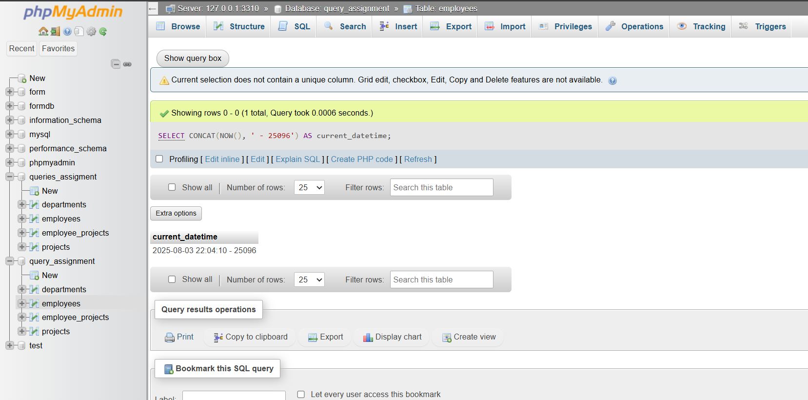

1. Extract the year, month, and day from hire_date

SELECT CONCAT(YEAR(hire_date), '-', MONTH(hire_date), '-', DAY(hire_date), ' - 25096') AS date_parts

FROM employees;

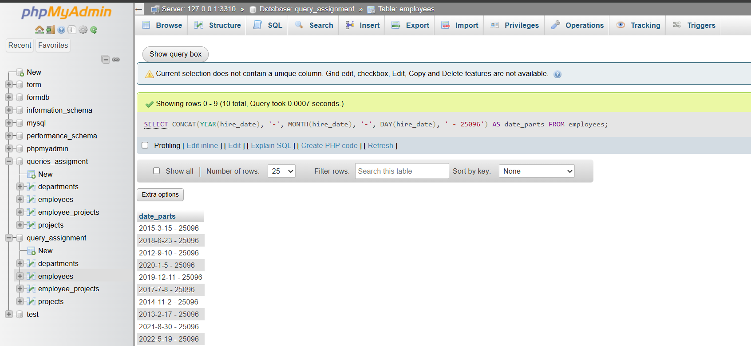

1. Show employees hired before 2020

SELECT CONCAT(first_name, ' ', last_name, ' - 25096') AS pre_2020_hires

FROM employees

WHERE hire_date < '2020-01-01';

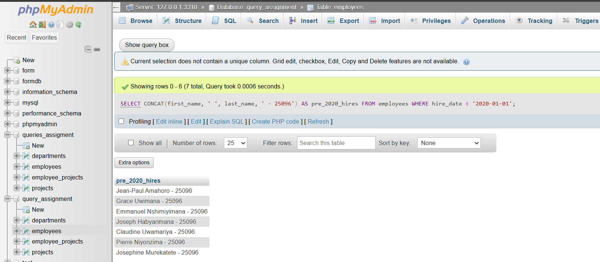

1. List projects that ended in the last 30 days

SELECT CONCAT(project_name, ' - 25096') AS recent_ended_projects

FROM projects

WHERE end_date >= DATE_SUB(CURRENT_DATE, INTERVAL 30 DAY)

AND end_date <= CURRENT_DATE;

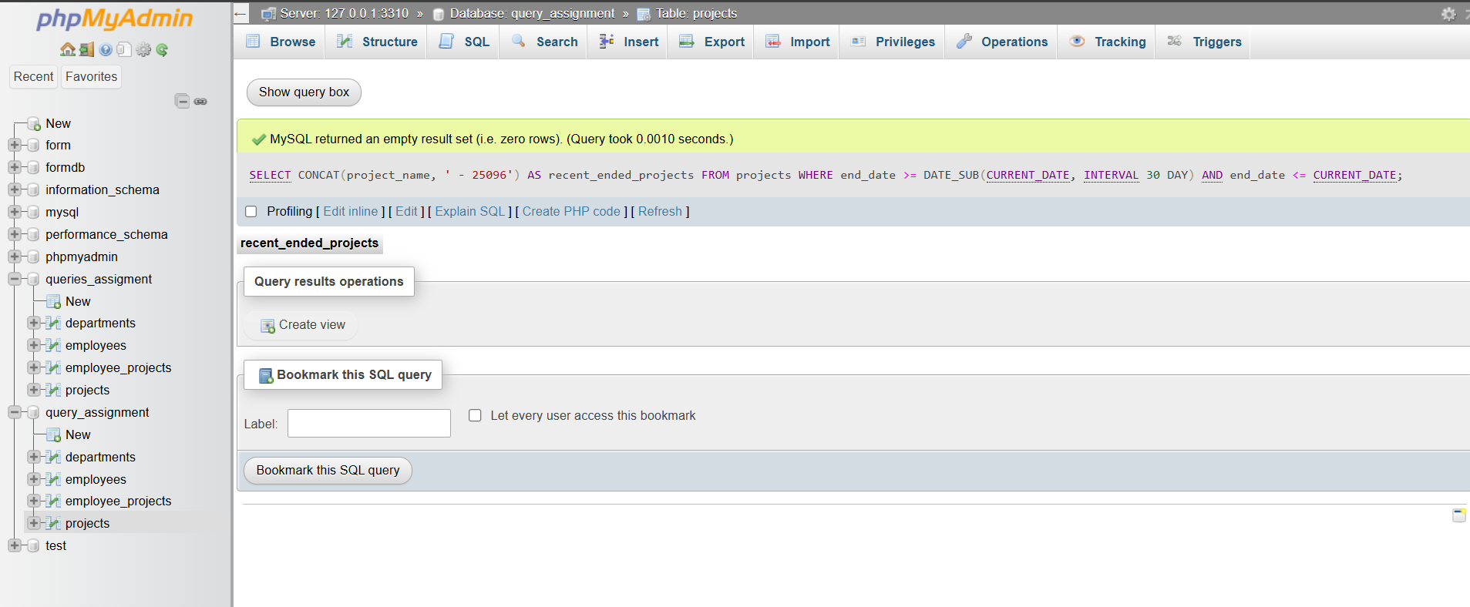

1. Calculate total days between project start and end dates

SELECT CONCAT(DATEDIFF(end_date, start_date), ' - 25096') AS duration_days

FROM projects

WHERE end_date IS NOT NULL;

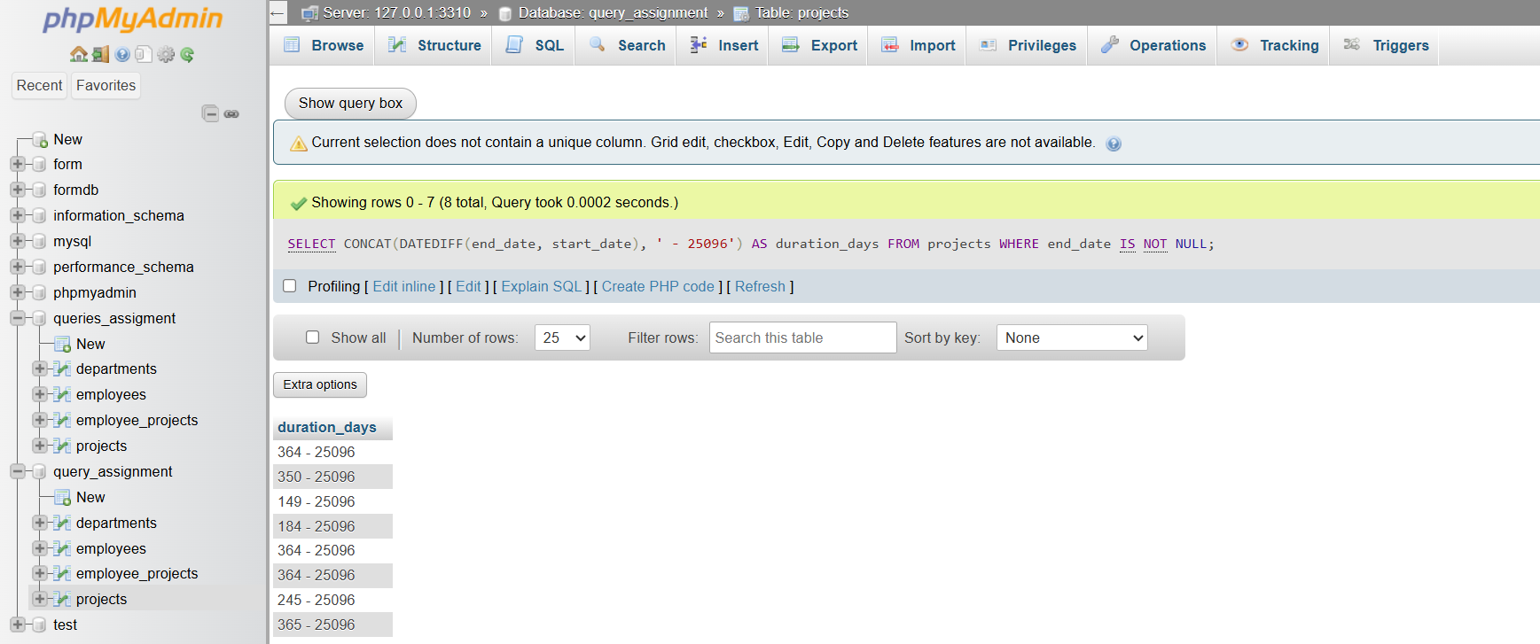

1. Format date '2025-07-23' to 'July 23, 2025' using CONCAT

SELECT CONCAT(MONTHNAME(hire_date), ' ', DAY(hire_date), ', ', YEAR(hire_date), ' - 25096') AS formatted_date

FROM employees;

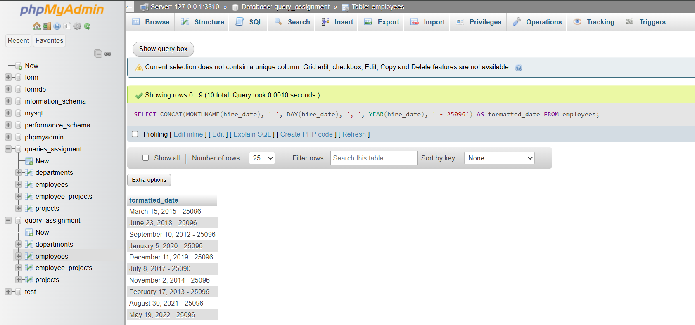

1. If project still active (end_date IS NULL), show 'Ongoing', else show end_date

SELECT CONCAT(

CASE

WHEN end_date IS NULL THEN 'Ongoing'

ELSE end_date

END, ' - 25096') AS project_status

FROM projects;

